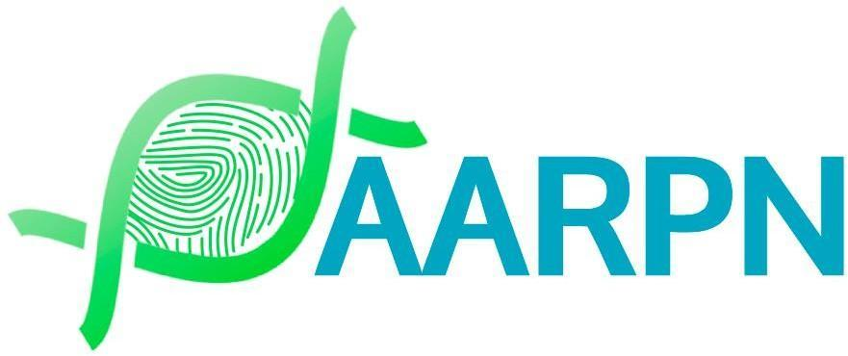

Complaints Form for a complaint against a Certified Practicing Nutritionist

Section 1: Complainant Information (not required for anonymous complaints)
Full Name: ___________________________________________
Contact Number: _______________________________________
Email Address: ________________________________________
Preferred Method of Contact: ( ) Phone ( ) Email
Relationship to the Certified Practicing Nutritionist:
( ) Patient/Client
( ) Family Member
( ) Healthcare Professional
( ) Other (Please specify): ________________________________

Section 2: Respondent (Certified Practicing Nutritionist) Information
Name of Certified Practicing Nutritionist: ____________________________________
AARPN CPN Number (if known): ________________________
Practice Address (if known): ___________________________________
Practice Contact Number (if known): ____________________________

Section 3: Complaint Details
Date of Incident: ________________________________________
Location of Incident: ______________________________________

Nature of Complaint:
(Please tick the relevant box or boxes)
( ) Alleged breach of AARPN Code of Conduct
( ) Non-compliance with Mandatory Declarations
( ) Failure to meet Fitness to Practice requirements
( ) Professional Misconduct
( ) Other (Please specify): _________________________________
Description of the Complaint:
(Please provide a detailed account of the incident, specifying actions or behaviour that you believe breached the AARPN Code of Conduct, Fitness to Practice, or professional standards. You may attach additional pages if needed.)

Section 4: Supporting Evidence
Do you have any supporting evidence?
( ) Yes (Please attach copies of documents, photos, or other relevant materials)
( ) No
List of Attached Documents (if any):
1. | 6.
2. | 7.
3. | 8.
4. | 9.
5. | 10.

Section 5: Preliminary Actions
Have you raised this issue with the Certified Practicing Nutritionist directly?
( ) Yes
( ) No
If Yes, what was their response?

Have you reported this complaint to any other authority (e.g., Health Complaints Commissioner)?
( ) Yes
( ) No
If Yes, please provide details:

Section 6: Desired Outcome
What outcome or resolution would you like to see as a result of this complaint?

Section 7: Consent for Mediation and Confidentiality
Would you consent to mediation as part of the resolution process?
( ) Yes
( ) No

Do you consent to AARPN sharing your complaint with the respondent for the purpose of addressing this issue?
( ) Yes
( ) No

Section 8: Declaration
I declare that the information provided in this complaint form is true and accurate to the best of my knowledge.
Signature: ___________________________________________ (not required for anonymous complaint)
Date: _______________________________________________

Section 9: Submitting the Complaint
Submission Instructions:
Email: Please send the completed form and any supporting documents to admin@aarpn.com.
Mail: Alternatively, mail the form to: AARPN Board, Complaint about CPN, PO Box 518, Glenelg, SA 5045.
Phone: For assistance with this form, please contact us at (08) 7228 6855.

