 | Certified Proof of Identity Document  - Instructions and Template for Completion

As a professional body it is important that AARPN verify the identity of our Certified Practicing Nutritionists (CPNs) in accordance with professional standards for self-regulating allied health professions.
To complete this document:
- You must have a myID account. If you do not have a myID account, you will need to create a myID account. Instructions can be found at: https://www.myid.gov.au/
Your identity level must be STANDARD or higher which means you will need proof of identity documents such as your Birth Certificate and your current Drivers’ Licence or Medicare Card to reach this level of identity verification on your myID account. See https://www.myid.gov.au/how-set-myid#identity-strength for a full list of acceptable forms of ID.
- You will then need to take a screenshot of the My Identity screen from your myID account, which you will then incorporate into the template below.
  - As described in more detail below - you will then take this template to a person who can certify documents. You will need to show your device to this person who is certifying the identity document - with your device showing them the myID page used for the screen shot.
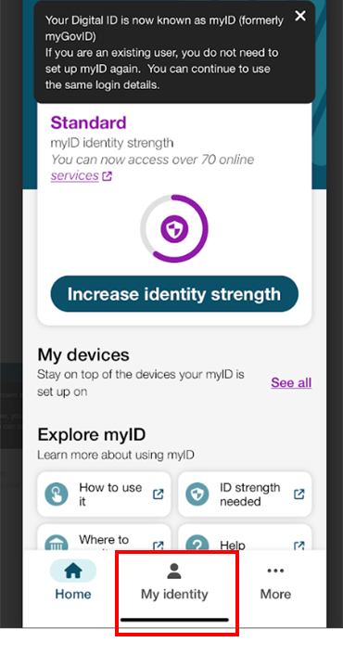 | 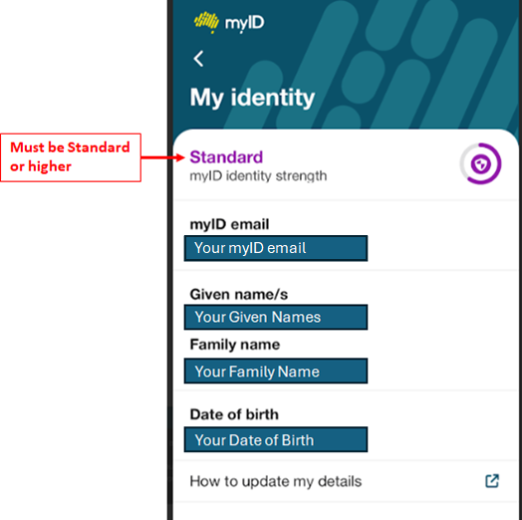

- To complete the below template - paste this screenshot from your My Identity screen into the Certified Proof of Identity Document Template on the final page of this document.

- Take a picture of your Drivers’ Licence or Photographic Working With Children Clearance card.
- Paste your Drivers’ Licence or your Photographic Working With Children Clearance card into the Certified Proof of Identity Document Template on the final page of this document. If using your Drivers’ Licence – ensure that you redact your Drivers’ Licence number – this can be done manually after you have printed your Certified Proof of Identity Document Template by crossing it through with a thick black marker.

The document certifier must be confident the copy of your identity documents are true to the original.
To certify a copy of your identity documents, your referee needs to do all the following:
- sight your original documents and the copy
- write on each copy
- sign their signature on each copy.

- A list of who can certify documents can be found at: https://www.servicesaustralia.gov.au/acceptable-referees-for-individual-healthcare-identifier-ihi-request?context=22591

- To sight the original of your My Identity screen, when in the presence of your Certifier, open your myID application on your phone and show them your My Identify screen.

- To sight the original of your Drivers’ Licence or Photographic Working With Children Clearance card, produce the original for the Certifier to sight.

- Ensure the Certifier signs across the images as instructed in the Certified Proof of Identity Document Template on the final page of this document.

- Ensure the Certifier completes all the required Certifier details as indicated in the Certified Proof of Identity Document Template on the final page of this document.

- Scan the completed document and send to admin@aarpn.com titled ‘CertID [Your Name]’.
- See the below example and then the template on the final page:

Certified Proof of Identity Document/Template: Example

Name of Practitioner: | Jane Smith
Address of Practitioner: | 101 Apple Lane, etc.

Paste your screenshot from the My Identity screen of your myID account below. Certifier is to write across the image: ‘This is a true copy of the original as supplied to me’ and sign with signature. | Paste your photograph of your Drivers’ Licence of Photographic Working with Children Clearance card below. Certifier is to write across the image: ‘This is a true copy of the original as supplied to me’, and sign with signature.
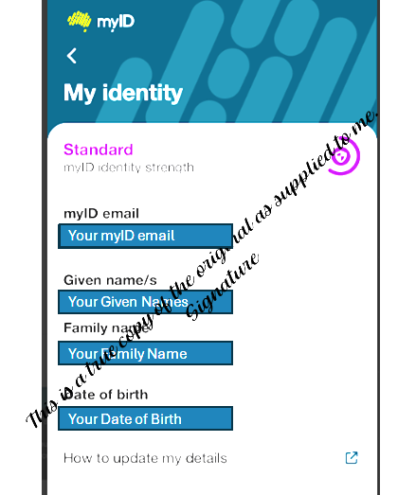 | 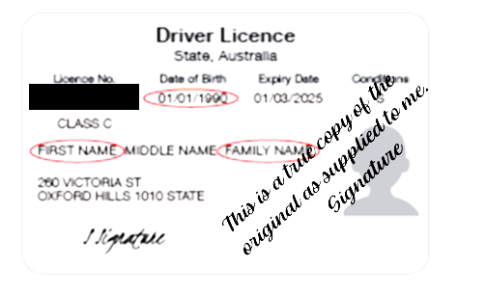  Certifier details:  Occupation: _____________________________________________  Full Name: _____________________________________________  Full Address: ____________________________________________  Phone Number: __________________________________________  Date of Certification: ____ / ____ / ________

Certified Proof of Identity Document/Template

Name of Practitioner:
Address of Practitioner:

Paste your screenshot from the My Identity screen of your myID account below. Certifier is to write across the image: ‘This is a true copy of the original as supplied to me’ and sign with signature. | Paste your photograph of your Drivers’ Licence of Photographic Working with Children Clearance card below. Certifier is to write across the image: ‘This is a true copy of the original as supplied to me’ and sign with signature.
Certifier details:

Occupation:
Full Name:
Full Address:

Phone Number:

Date of Certification:

