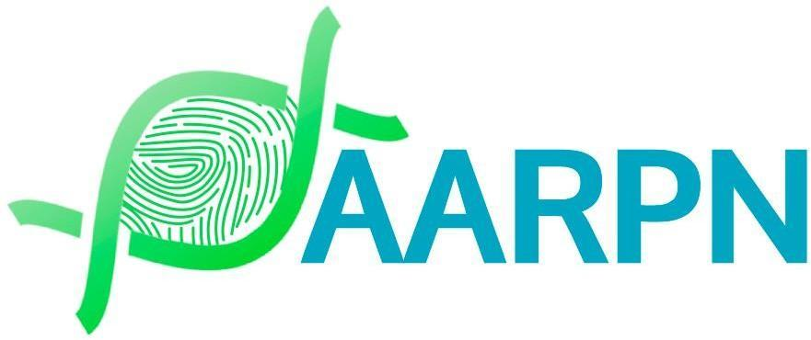

Complaint Form
This form is for submitting a complaint regarding the practices, policies, or actions of ‘The Australasian Association and Register of Practicing Nutritionists (AARPN)’.

Section 1: Complainant Information (not required for anonymous complaint)
Full Name: ___________________________________________
Contact Number: _______________________________________
Email Address: ________________________________________
Preferred Method of Contact:
( ) Phone
( ) Email
Are you affiliated with AARPN?
( ) Yes (e.g., Practitioner Member, Staff)
( ) No (e.g., Public, Patient/Client)

Section 2: Nature of the Complaint
Please indicate the nature of your complaint:
( ) AARPN Policy or Procedure
( ) Conduct of AARPN Representatives
( ) AARPN Membership or Credentialing Process
( ) Handling of a Previous Complaint
( ) Other (Please specify): _________________________________
Section 3: Complaint Details
Date of Incident or Issue: ____________________________________
Description of the Complaint:
(Please provide a detailed description of the issue, including relevant dates, names of individuals involved, and any policies or procedures you believe were not followed. You may attach additional pages if needed.)

Section 4: Supporting Evidence
Do you have any supporting evidence?
( ) Yes (Please attach copies of documents, emails, or other relevant materials)
( ) No
List of Attached Documents (if any):
1. | 6.
2. | 7.
3. | 8.
4. | 9.
5. | 10.

Section 5: Preliminary Actions
Have you raised this issue with AARPN staff or practitioner member representative, or the relevant individual(s) before submitting this complaint?
( ) Yes
( ) No
If Yes, what was the outcome or response?

Section 6: Desired Outcome
What outcome or resolution would you like to see as a result of this complaint?

Section 7: Confidentiality and Consent
Do you consent to the AARPN Board sharing this complaint with relevant personnel or committees for the purpose of resolving this issue?
( ) Yes
( ) No

Would you like this complaint to remain anonymous?
( ) Yes
( ) No

Section 8: Declaration
I declare that the information provided in this complaint form is true and accurate to the best of my knowledge.
Signature: ___________________________________________ (not required for anonymous complaint)
Date: _______________________________________________

Section 9: Submission Instructions
Email: Please send the completed form and any supporting documents to admin@aarpn.com.
Mail: Alternatively, mail the form to: AARPN Board, Complaint about AARPN, PO Box 518, Glenelg, SA 5045.
Phone: For assistance with this form, please contact us at (08) 7228 6855.

